I
n this session we will look at what is gateways and XOR gateway.

Gateways are BPMN flow elements, which are used to control how sequence flows interact as they converge and diverge within a process.
Gateways enable the implementation of branching, forking, joining and merging of the paths in a business process diagram.
In order to define different process flow behaviors, BPMN provides different types of Gateways. These are defined with different icons within the diamond shape of the Gateway. Totally, BPMN 2.0 defines seven different types of Gateways.

Camunda Gateways and XOR gateway
Types of Gateways

- Data-based Exclusive Gateway (XOR)
Exclusive gateway is a diversion point of a business process flow. For a given instance of the process, there is only one of the paths can be taken
- Parallel Gateway
Model fork / join concurrency.
- Inclusive Gateway
Model conditional fork / join concurrency.
- Event-based Gateway
Model decisions based on events.

Data-based Exclusive Gateway (XOR)

- Exclusive gateway: An exclusive gateway (also called the XOR gateway or, in more technical terms, the exclusive data-based gateway), is used to model a decision in the process. When the execution arrives at this gateway, all outgoing sequence flows are evaluated in the order in which they have been defined. The sequence flow which condition evaluates to ‘true’ (or which doesn’t have a condition set, conceptually having a ‘true’ value defined on the sequence flow) is selected for continuing the process.
- Only one sequence flow: Note that only one sequence flow is selected when using the exclusive gateway. In case multiple sequence flow have a condition that evaluates to ‘true’.
- Runtime exception: If no sequence flow can be selected (no condition evaluates to ‘true’) this will result in a runtime exception, unless you have a default flow defined. One default flow can be set on the gateway itself in case no other condition matches - like an ‘else’ in programming languages.

Exercise:

- We will model below process to demonstrate use of exclusive OR gateways.

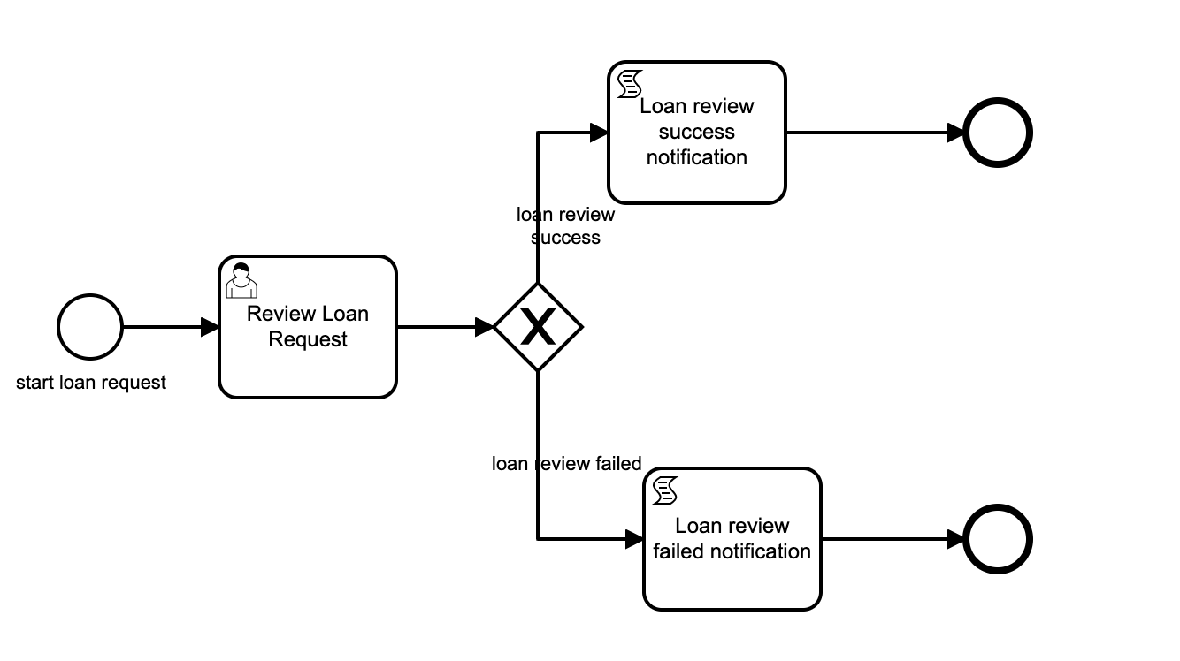

Process properties:
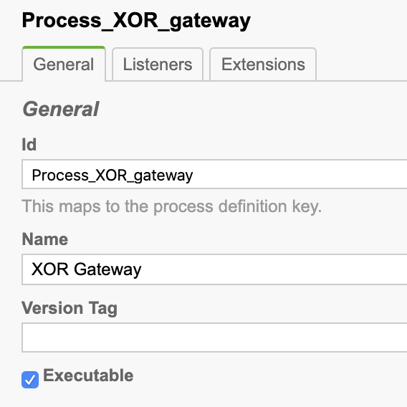

Id: Process_XOR_gateway
Name: XOR Gateway

2. Start event “Start loan request”.
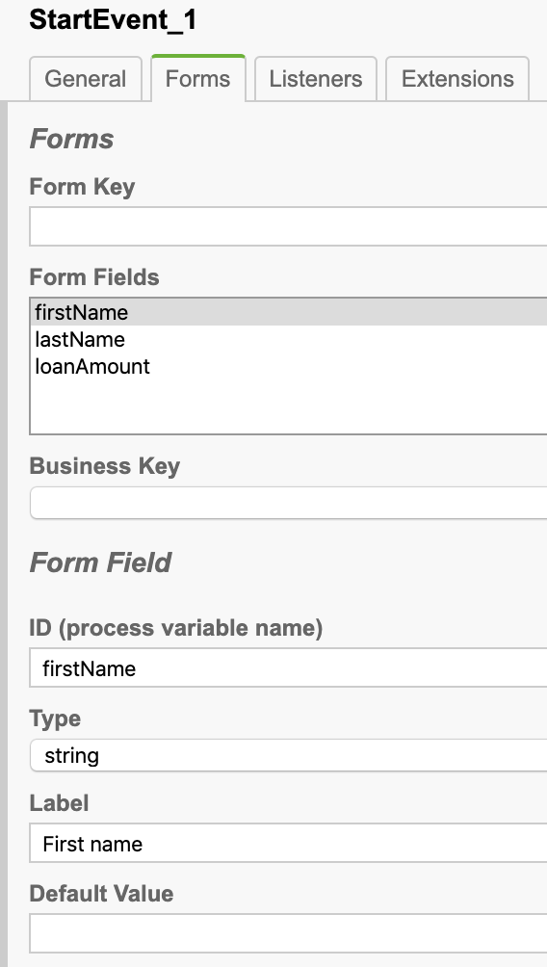
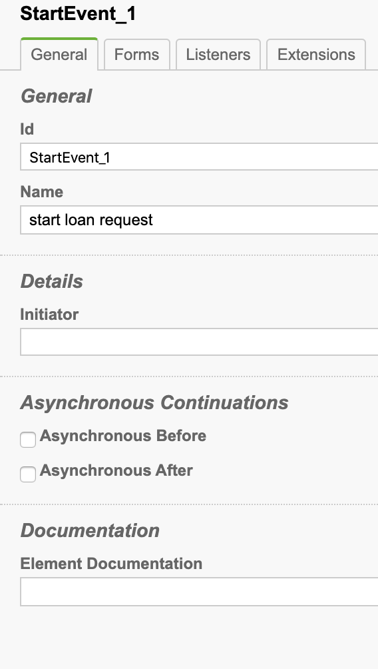
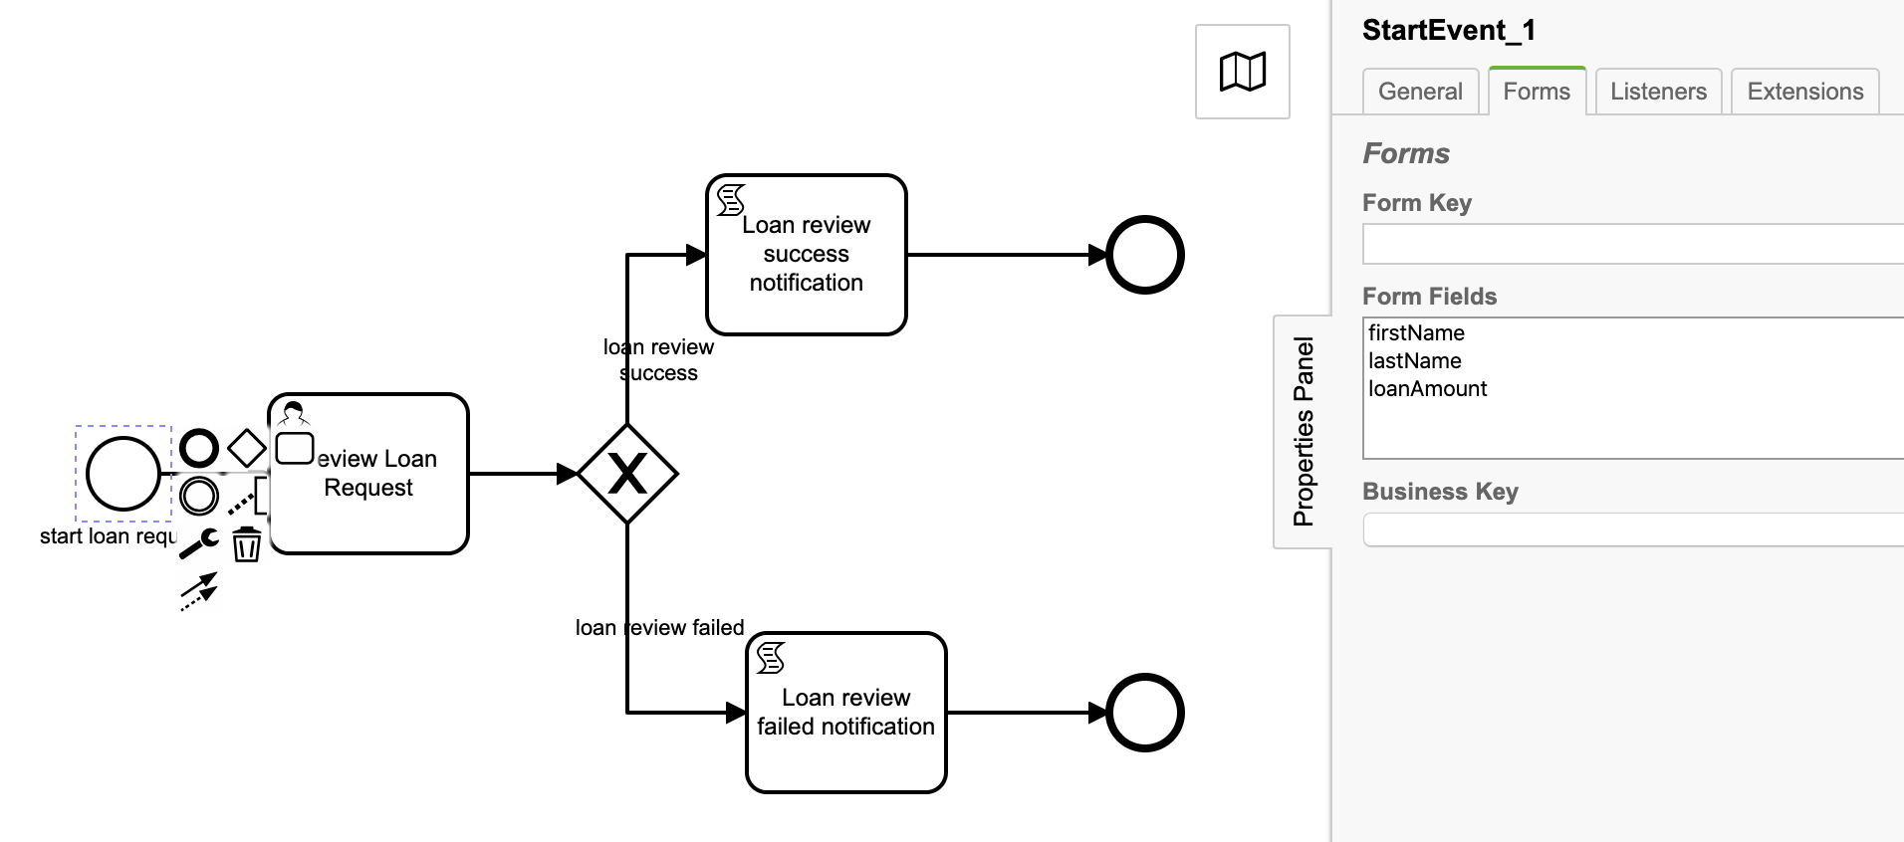
Configure start event form to apply loan request.

3. User task Review Loan Request
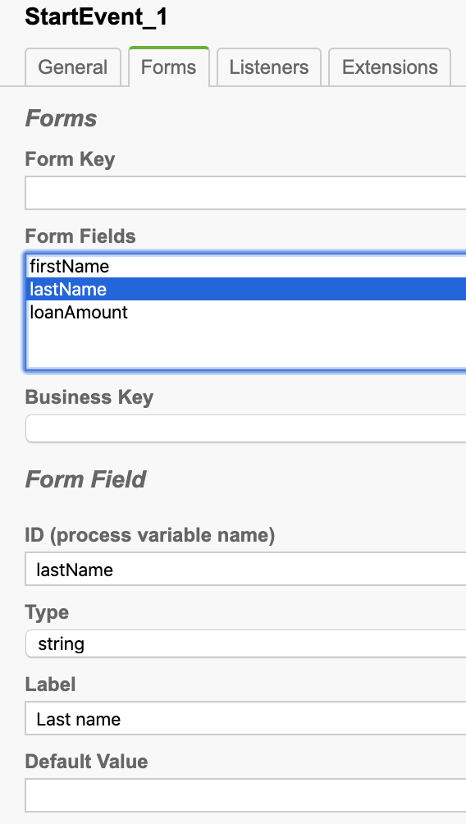
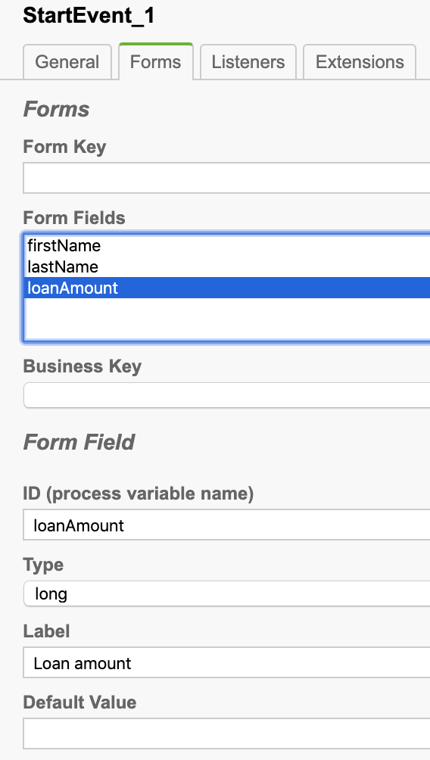
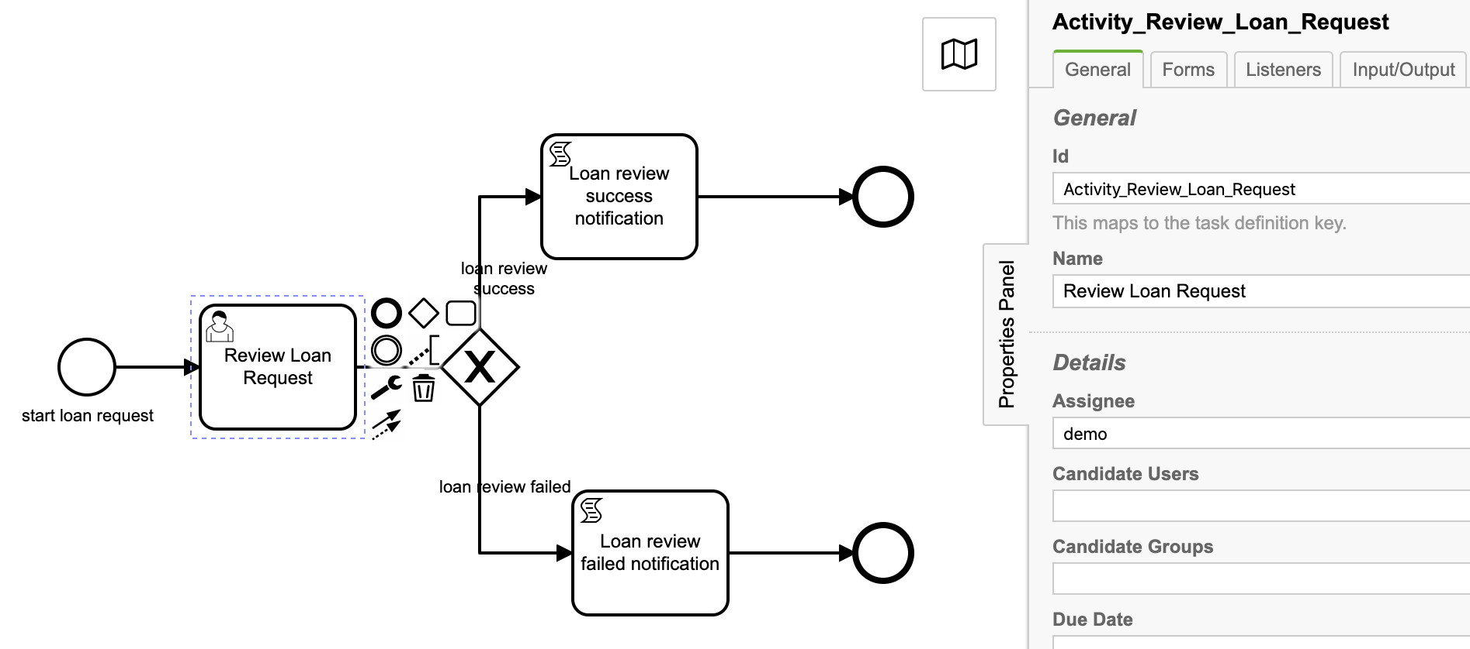
Configure user task form to review loan request.
User task properties: (General tab)
Id: Activity_Review_Loan_Request
Name: Review Loan Request
Assignee: demo

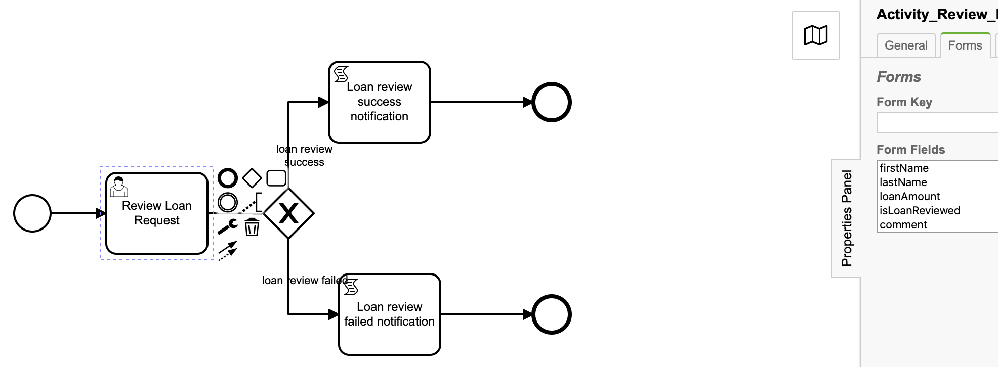
User task form properties: (Form tab)
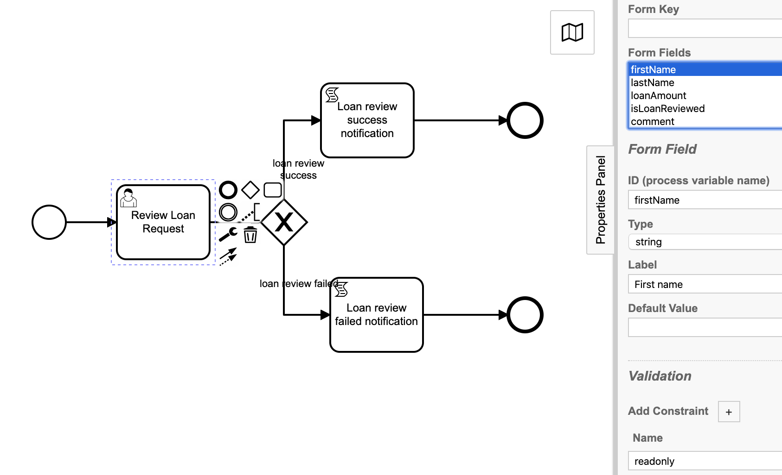
For review loan request user task, form fields firstName, lastName, loanAmount marked as readonly as these fields value are to be provided by loan requester and loan review is not going to update these fields value. Reviewer should be able to enter values for fields isLoanReviewed and comment.
Base on the loan reviewer input, process will take decision through XOR gateway to notify loan requester about the success or rejection of loan request review.

Constraint
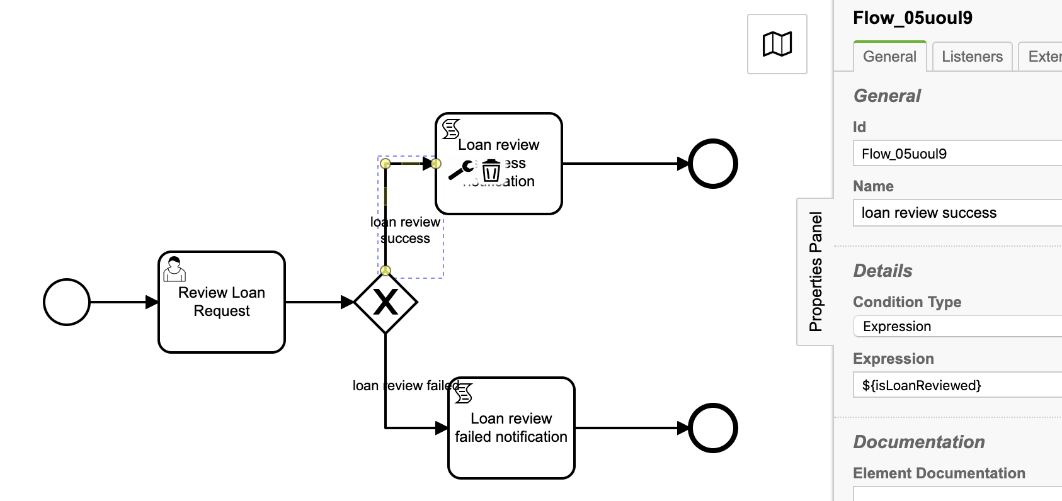
Loan review success:

Id: Flow_05uoul9
Name: loan review success
Content Type: Expression
Expression: ${isLoanReviewed}
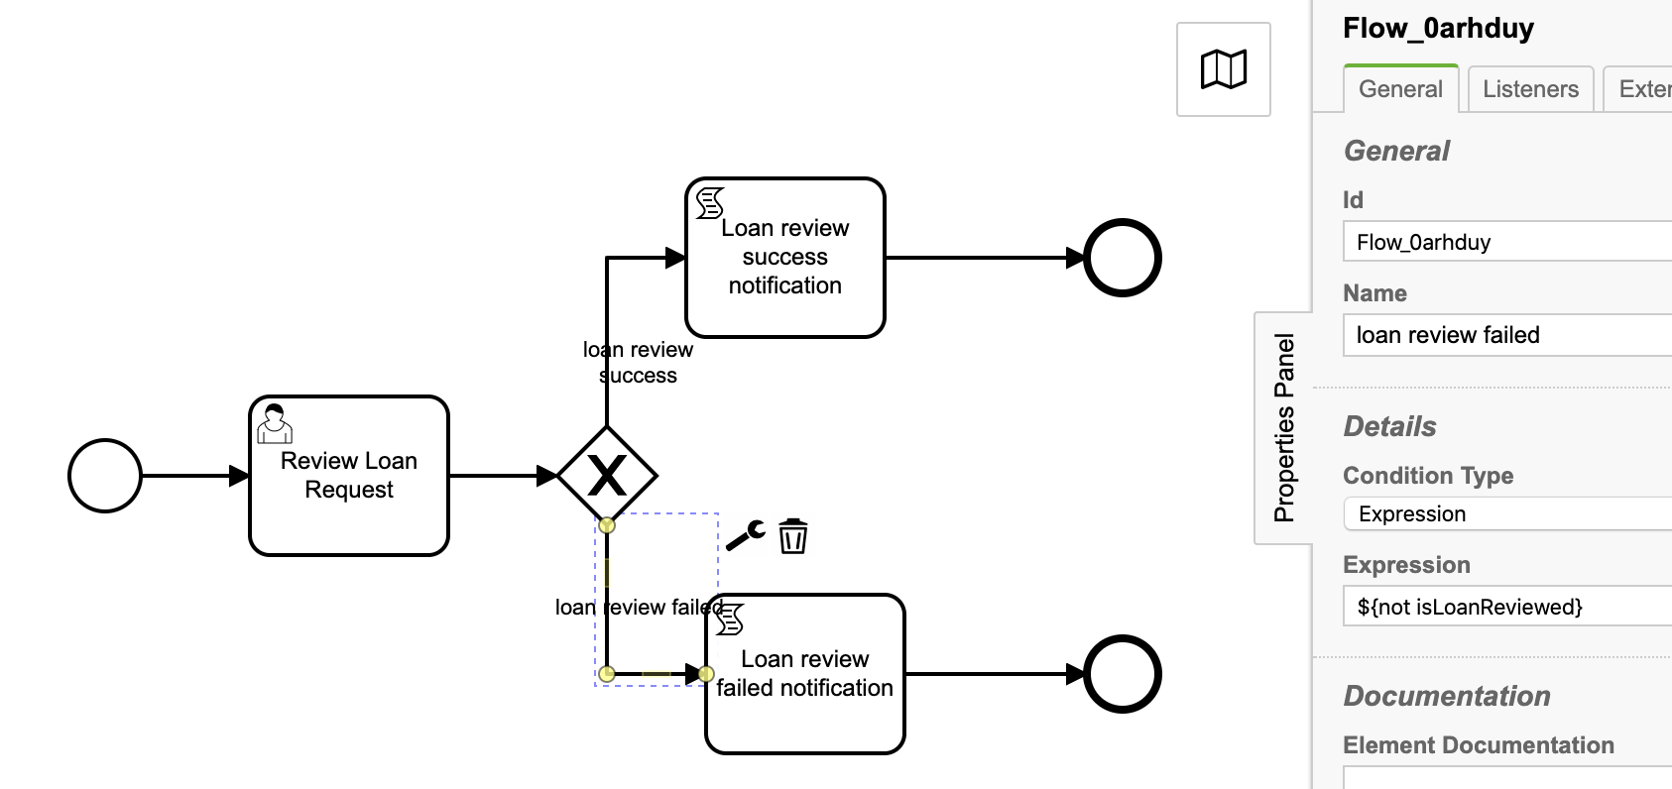
Loan review failure:
Id: Flow_0arhduy
Name: loan review failed
Content Type: Expression
Expression: ${not isLoanReviewed}

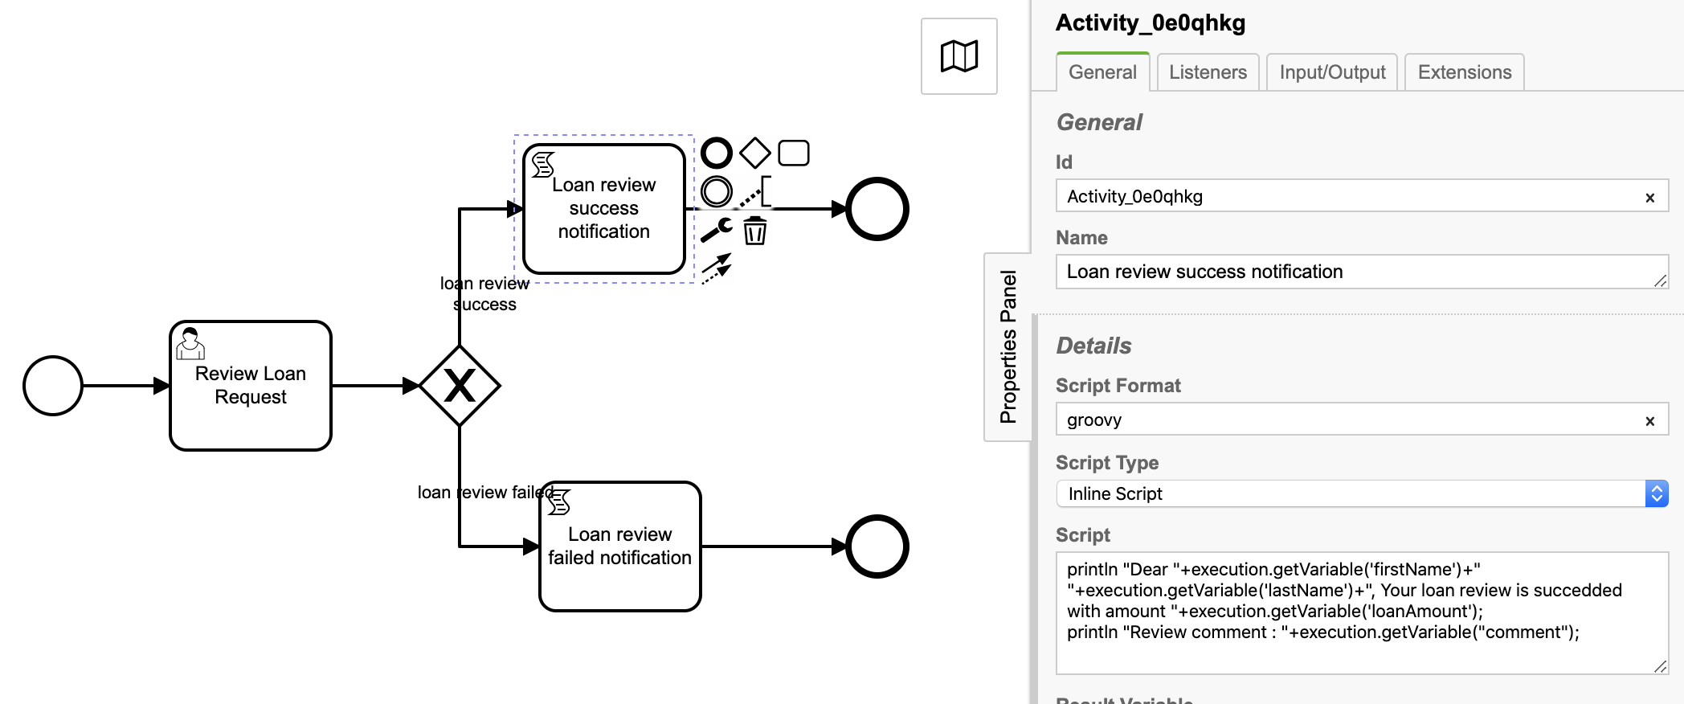
Script task: Loan review success notification

Id: Activity_0e0qhkg
Name: Loan review success notification
Script Format: groovy
Script Type: Inline Script
Script:
println "Dear "+execution.getVariable('firstName')+" "+execution.getVariable('lastName') +", Your loan review is succedded with amount "+execution.getVariable('loanAmount');
println "Review comment : "+execution.getVariable("comment");

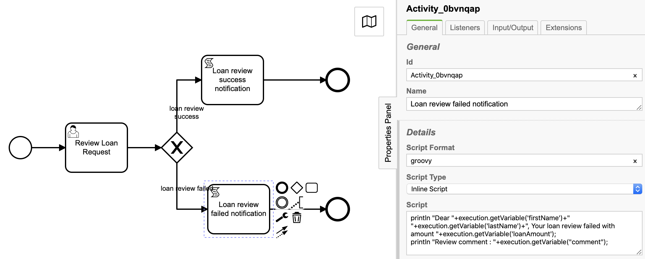
Script task: Loan review failed notification

Id: Activity_0bvnqap
Name: Loan review failed notification
Script Format: groovy
Script Type: Inline Script
Script:
println "Dear "+execution.getVariable('firstName')+" "+execution.getVariable('lastName') +", Your loan review failed with amount "+execution.getVariable('loanAmount');
println "Review comment : "+execution.getVariable("comment");

Deploy and start the process:
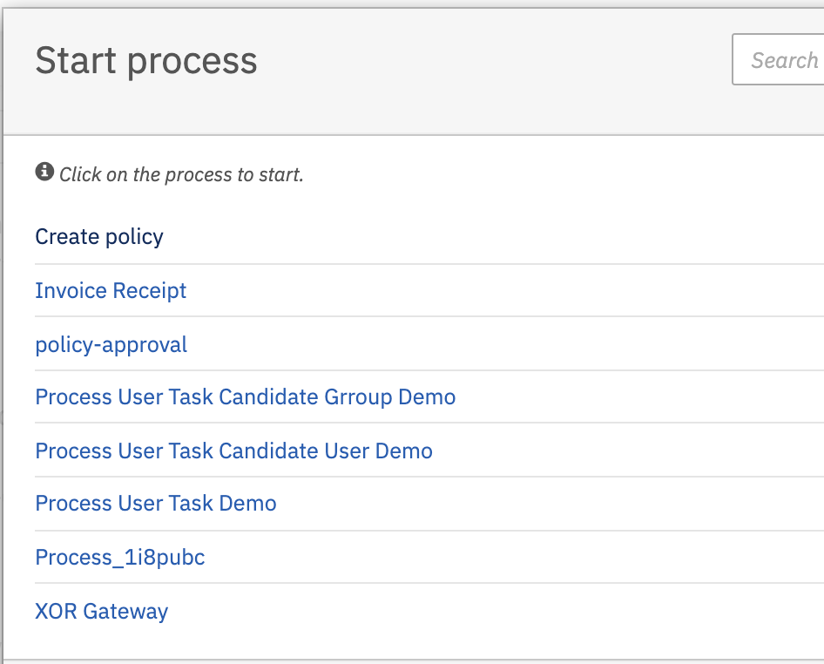

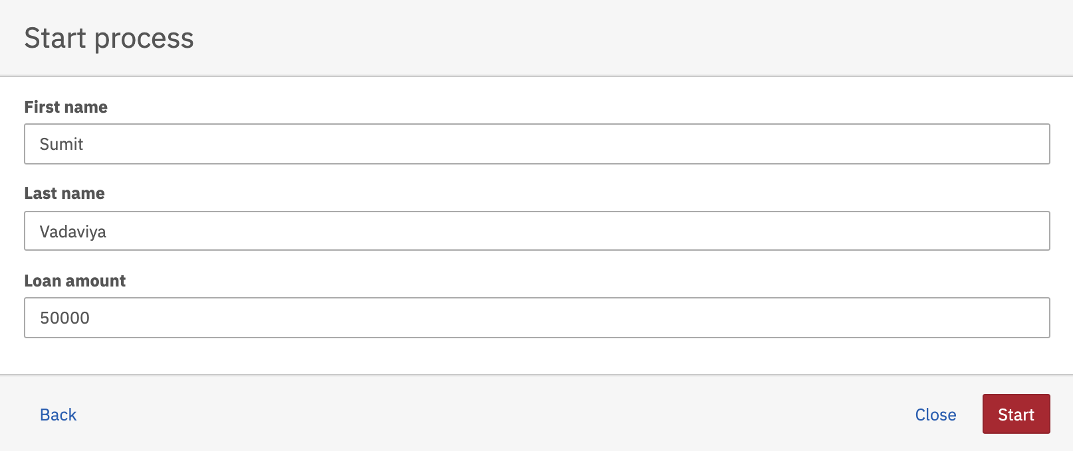
Hit the XOR Gateway. It will open start request loan form as below.

Fill-up the form and hit Start button.

As per process definition, after process start event executed, Review loan request user task is created and it is assigned to demo user.

User task Review loan request
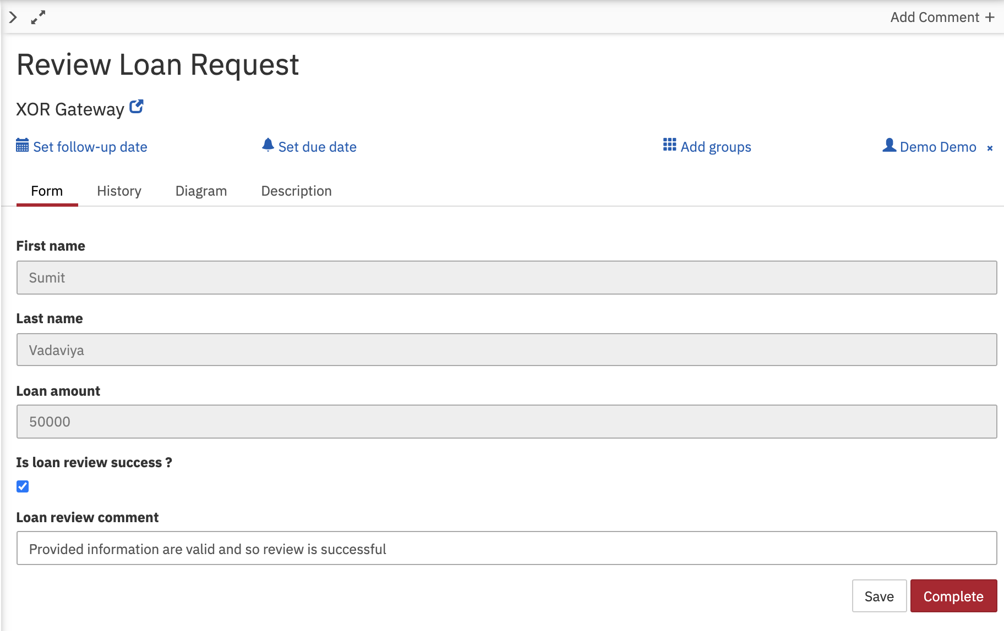
Open the user task Review loan request
Form values:
Is loan review success ?: True
Loan review comment: Provided information are valid and so review is successful
Hit the Complete button to submit loan request review.
As per process definition, script task Loan review success notification will be executed to send notification of review success.

Observe tomcat console output

Dear Sumit Vadaviya, Your loan review is succedded with amount 50000
Review comment : Provided information are valid and so review is successful

